Multiview Image Generation

We received 8 samples of the masks we were trying to get printed for Videocon at 600dpi. Each of these masks are supposed to have 2560x1440 pixels. Each super pixel consists of 10 pixels with the two in middle blank and others black blocking light. This was repeated 256 times horizontally and 144 times vertically. However the film we received did not have a square hole but a rectangular one. In the original film, the square was supposed to be of 84.7 um side whereas the received film had one 84.7 um side and other “95.3” um side.

We first kept two of these masks over each other and saw the changing dots sizes as mentioned in the displayblocks article. This made us believe that the masks had holes at regular intervals and they were small enough to be able to generate what we exactly need.

We first opened the redbox multiview image we generated, on Videocon A55HD. When we put the mask on, the alignment was off because the mask was a little bigger in width. When viewed from a distance, the image appeared very broken and fragmented as shown below. Changing the viewing angle did not change the view much. There was some distortion and “parallax-looking” effect although overall the object is not decipherable.

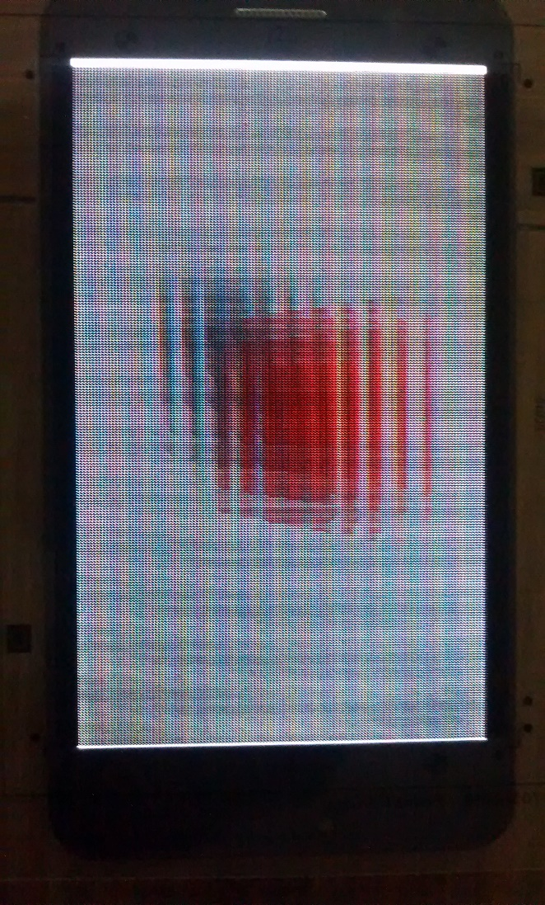

We then downloaded a bunch of images from the displayblocks site. These images give better results than the one we generated. We could see better parallax when these images were viewed through the mask. We then compared the view on two phones Moto G and Videocon A55HD. The effect was more realistic in Moto G as compared to Videocon. The objects were still not very decipherable. Out of these images the ones with dinosaur looked best.

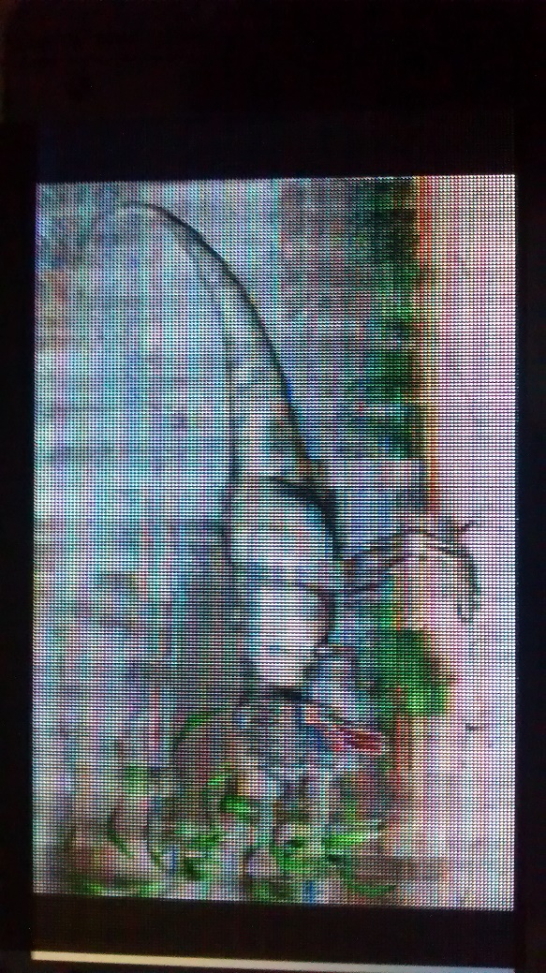

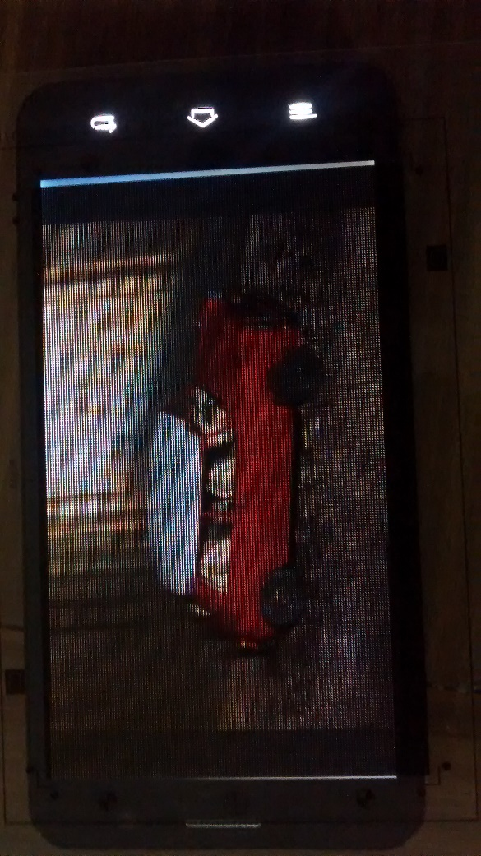

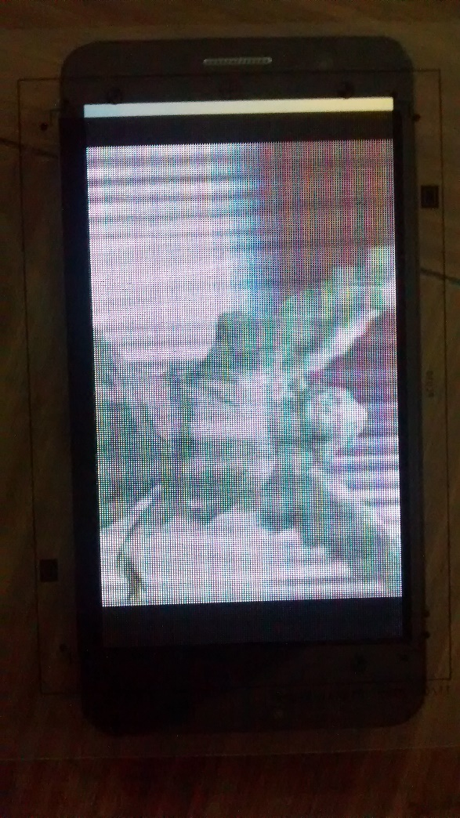

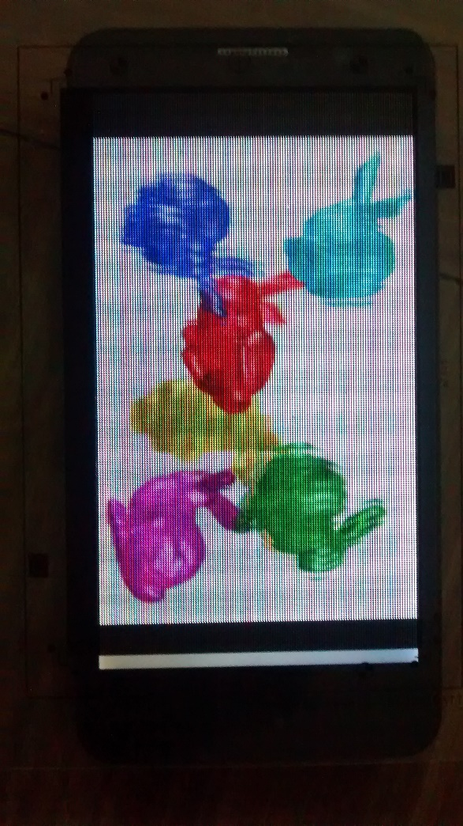

The generated redbox multiview image, however does not look at all like these other light field images downloaded from the net. We then reached to the conclusion that we were generating the image in the wrong way. We were assuming that when the camera moves along a line to record different images, the point at which it is looking at will also move linearly. But that is not the case, we need to keep the gaze point fixed while moving the camera and then generate the multiview image from this setup. This is the resulting generated image.

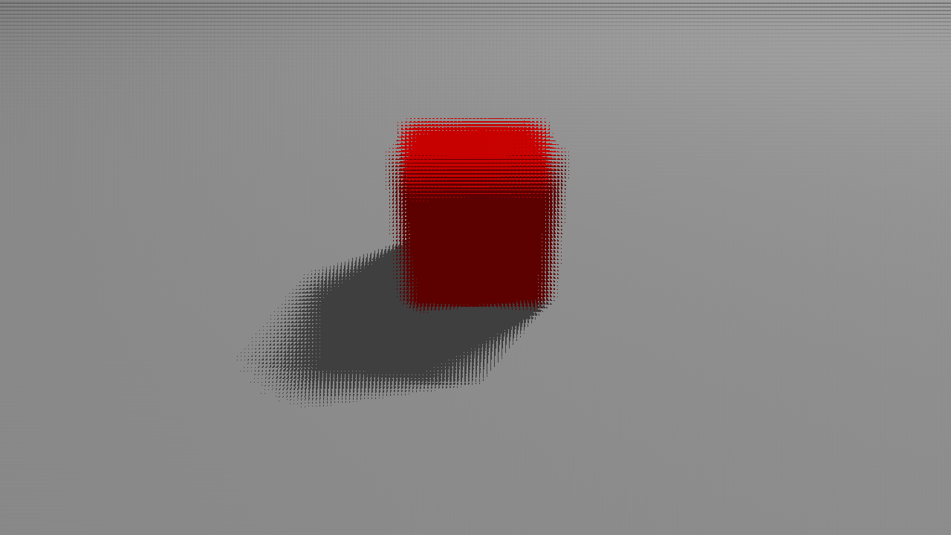

This image looks more closer to the ones downloaded from the net. We then tried using this image with the received masks but could not get the desired results. The fact that the pixels are misaligned and the holes are appearing as rectangles instead of squares might be the problem why were are not able to see the phenomenon in practice. We now need to backcalculate how to generate the image in tune with the received prints.